~``` Afr-Mali-Djenne-Male head

NB1265

Djenné statuary of a male

14th-15th centuries

Height:

Weight:

Terracotta

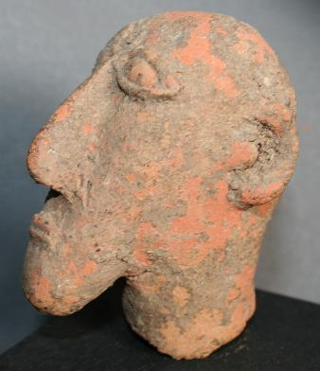 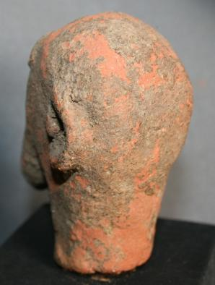

Djenné statuary emerged ca A.D. 700 and flourished until ca. 1750. These terracottas were manufactured by diverse groups of the Inland Niger Delta region of present-day Mali, with the ancient urban center of Djenné-Jeno as its cultural focal point.

This very rare terracotta head of a male with Semitic features dates to the 14th-15th centuries when Muslim Arab traders were traveling caravan routes across the Sahara desert to the trading areas of west Africa along the Niger River. This terracotta was excavated in Djenné which houses an ancient Mosque that dates to the 14th century as well and this individual, who was of high rank, may have been one of the leaders who was responsible for the building of the Mosque.

